append() method is a overloaded method , method name is same arguments are different

public StringBuffer append(int i)

public StringBuffer append(long l)

public StringBuffer append(boolean b)

public StringBuffer append(double d)

public StringBuffer append(folat f)

Eg: String_Append_Method_Overloading

public StringBuffer insert(int index , int i );

public StringBuffer insert(int index , float f );

public StringBuffer insert(int index , long l );

public StringBuffer insert(int index , double );

public StringBuffer insert(int index , boolean b );

public StringBuffer insert(int index , Object o )

Eg: String_Insert_Method_Overloading_35

public StringBuffer delete( int begin , int end ) // deletes data from specified index to end-1

public StringBuffer deleteCharAt(int index) // deletes character at specified index

Eg: StringBuffer_Delete_Eg37

public StringBuffer reverse()

Eg:StringBuffer_Reverse_Eg38

// go through the code

public StringBuffer setLength()

// used to set only specified no of characters and remove all remaining characters

Eg: StringBuffer_Set_Length_Eg39

public void trimToSize()

This is method is used to deallocate the extra allocated free memory such that capacity and size are equal .

Eg: StringBuffer_trimToSize()_Eg40

public void ensureCapacity(int capacity)

It is used to increased the capacity dynamically based on our requirement . because normal StringBuffer and every time jvm reaches the maximum capacity for object and after that increasing its size is a costly operation . so to avoid that ensureCapacity() method is used .

Eg: StringBuffer_ensureCapacity_Eg41

StringBuffer

Every method present in StringBuffer is synchronized, so that only one thread is allowed to use the object at a time ,it would create performance problems , so to overcome this we use StringBuilder

StringBuilder

It is introduced in the jdk 1.5 version

At a time more than one thread can use the object so it is not thread safe .

Threads are not required to wait ,so the performance is high .

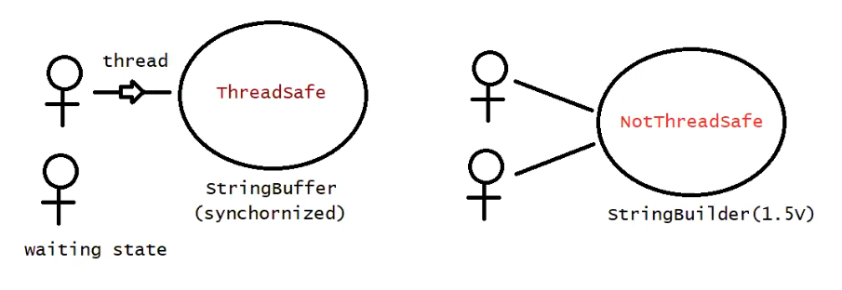

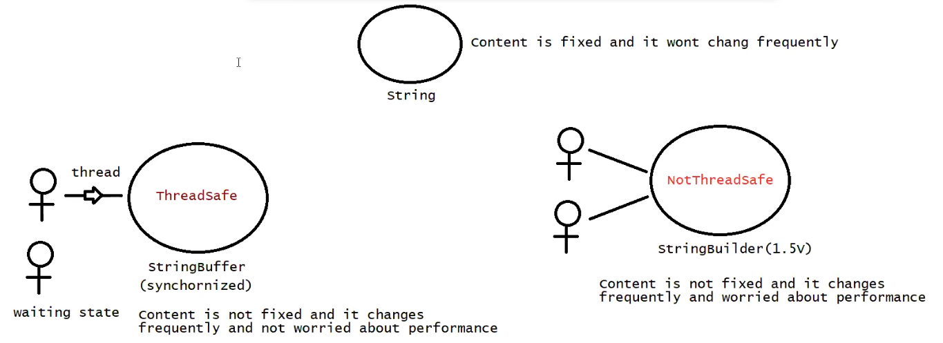

String vs StringBuffer vs StringBuilder

String -> we can choose if the content is fixed and not changed frequently

StringBuffer -> we can choose if the content is not fixed and changes frequently and it should thread safe (commonly used in banking applications )

StringBulilder -> we can choose if the content is not fixed and changes frequently and it is not thread safe

Method Chaining

Most of the methods in the String, StringBuffer , StringBuilder the return type is same . hence after applying method on result we can call another method which forms method chaining .

Note : here the after method works based on the return type of the before method , and all of them works on the same object

Eg: Method_Chaning_Eg42

Eg: Copy_Of_String_Eg43

// length property is for array and length() is of String type

Eg: Capital_String_Eg44

// go through the program.

Eg: SmallerCase_String_Eg45

// go through the program

Eg: Opposite_Case_Converting_Eg46

// go through the program

Eg: Reverse_The_String_Eg47

// go through the program

Eg: Reverse_The_String_2_Eg48

// go through the program

String_object . split(“ “)

Splits this string around the matches of the given regular expression( should be given in bracket)

Eg: String_Eg49

// go through the program

Eg: String_Eg50

// go through the program

Eg: String_Eg51

// go through the program

Eg: String_Eg52

Since assigning s2 to s1 is a runtime operation memory is allocated in the heap.

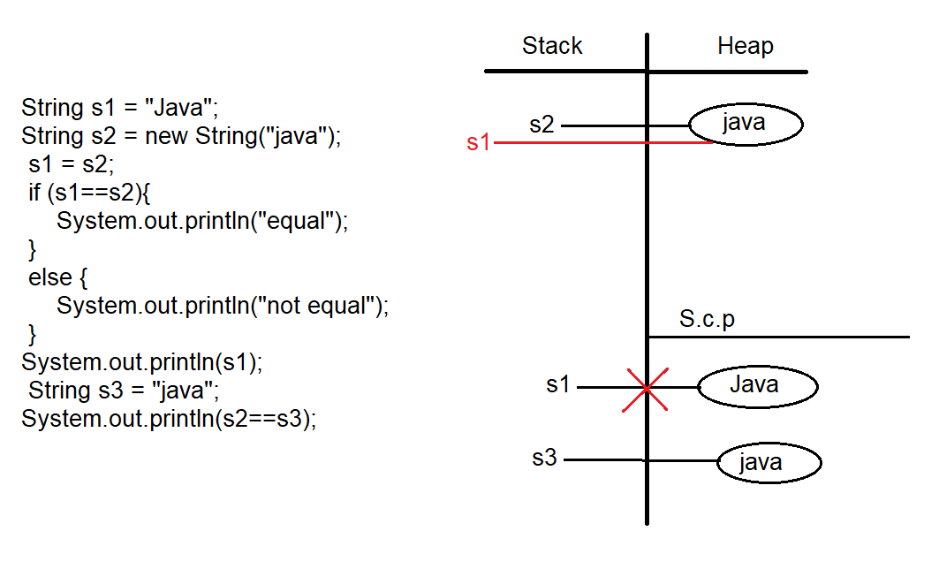

Eg: String_Eg53

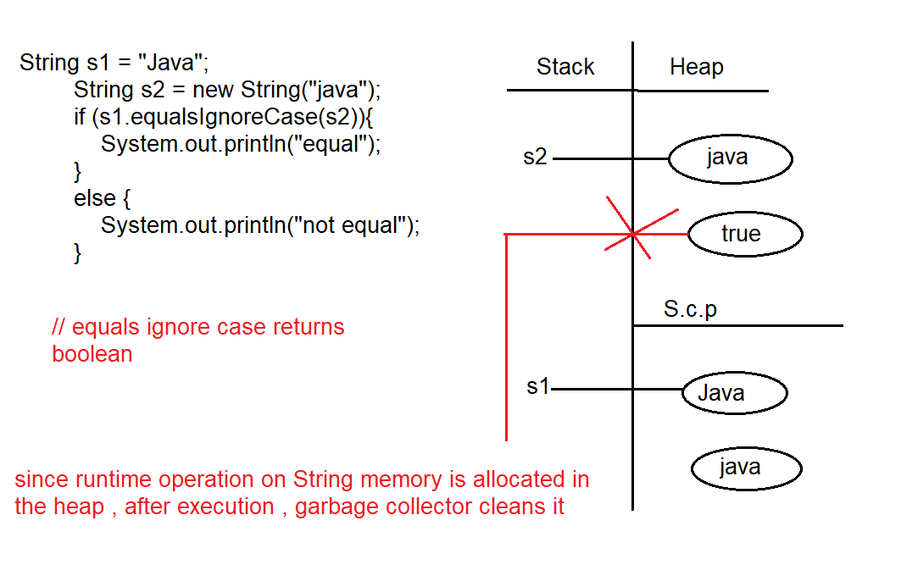

Eg: String_Eg54

// go through the code

Eg: String_Eg55

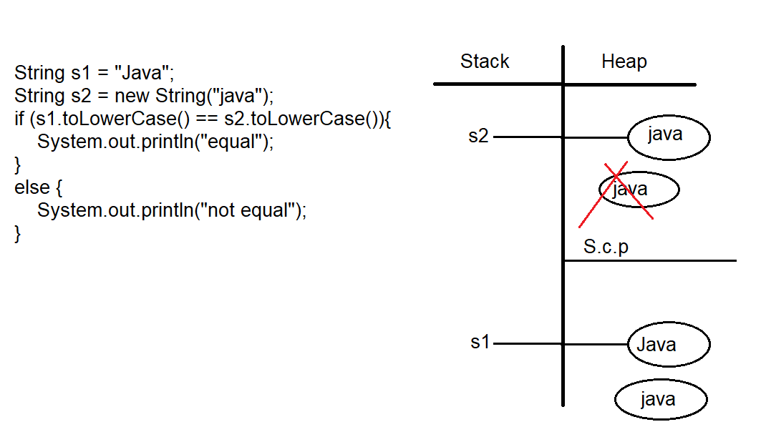

// while executing if condition since runtime operation and data is being changed a new object will be created in the heap . And even though runtime operation is made on s2 , and there is no change in its data s2 , no new object is created ,

The 2 objects in the heap have different address , else block is excueted

When else block is executed ,as the object is not collected by reference variable garbage collector cleans it .

Eg: String_Eg56

// go through the program

Eg: String_Eg57

// go through the program

Eg: String_Eg58

// go through the code

Eg: String_Eg59

// since s1 and s2 are of String type we are assigning s2 data to s1 so no compilation error .

Eg:String_Eg60

// String is immutable , we cannot add data on same object , if we to try to perform any operation on String (using method ) a new object is created for that change , and if that object is not collected by reference variable it is cleared by garbage collector .

Eg: String_Eg61

// StringBuilder is mutable , we can add data on same object .

Eg: String_Eg62

// go through the code

Eg: String_Eg63

// whenever you try to print a reference , internally toString() method is called.

Note: if a class is final then that class cannot be inherited or extended , String class is final .

Eg:String_Eg64

“” (no space is considered ) and “ “ are different

// go through the program

Eg: String_Eg65

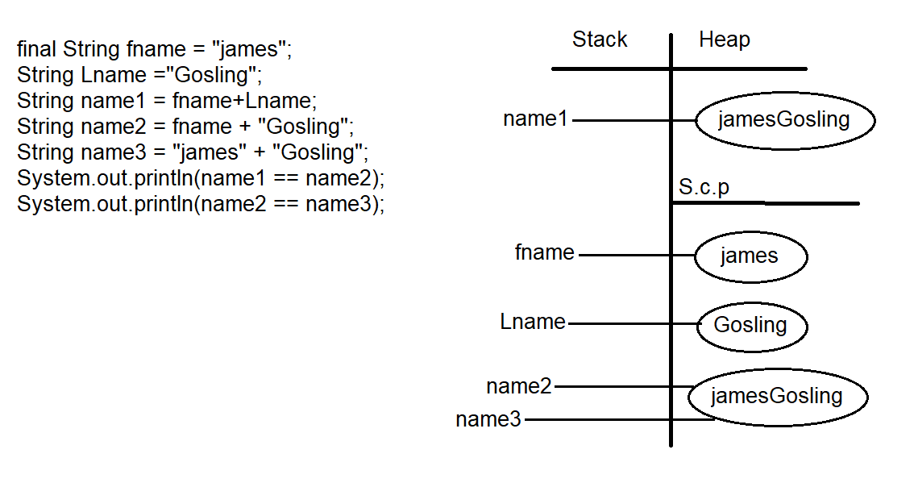

final variables are evaluated at compile time